Systems Drawing Reconfigure Process 9/05/07

Step 1
Save the reconfiguration drawing as a new number using an “R” for layout type.
Example: D000000_00_00_R01_S
(Note: A new drawing must be created if previous drawing was ordered to keep original ordered drawings in tact.)

Step 2
Rearrange or redraw furniture to new layout and workgroup new plan in desired workgroups. Everything must be in a workgroup. Therefore, if there are no requested workgroups group entire drawing as “New Plan”.

Step 3
Go back to the original ordered drawing. Type “update” in the command line. Then select “Extract B.O.M.” from the Program pull down menu.

Step 4
File name should default to drawing number. Check the box next to “Breakout Tiled System” and “Ignore Workgrouping”. Select Run.
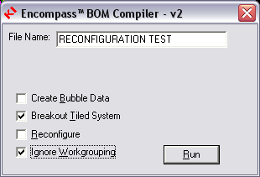
Step 5
Return to new drawing and select “Extract B.O.M.”

Step 6
File name should default to drawing number. Check the “Breakout Tiled System” box first and then check the “Reconfigure” box. Select the original drawing number from the pull down in the “Existing” section and select Run.
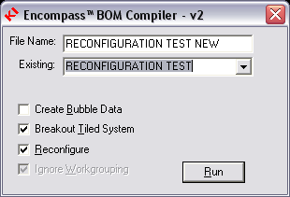

Step 7
Type IRC at the command line. This will prompt for an insertion point for the “BUY”, “LEFTOVER” and “EXISTING” product workgroups. Select desired location for these workgroups.

(Note: DO NOT explode these workgroups.)

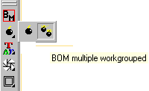
Step 8
Run the Workgrouped BOM (ABOM)
and place Bill of Materials on drawing.

Step 9
Insert “Reconfigure Drawing Note” and fill in
“T.B.D’s.”

Step 10
After checks are complete import the txt file with “reconfig” after the drawing number into ESPEC. Workgroups: Buy, Existing, Leftover and New Plan should appear in ESPEC. Leave all these workgroups in ESPEC but “soft” delete the Existing, Leftover and New Plan workgroups so they do not appear in the sif file.

Note:
To do a reconfigure using the “leftover” product from an existing reconfigure drawing repeat steps 1-10 except in step 4 select only the “leftover” workgroup to extract.

